Lpac AUDITorium 16th May
8pm
The Wheel Of Control
'You wouldn’t steal a car. You wouldn’t steal a handbag. You wouldn’t steal a television... Would you? What if someone told you there were no consequences? How far would you go? Would you know when to stop?
Psycho Reaction present ‘Wheel of Control;’ a dare game of risk and chance.'
Includes free cakes
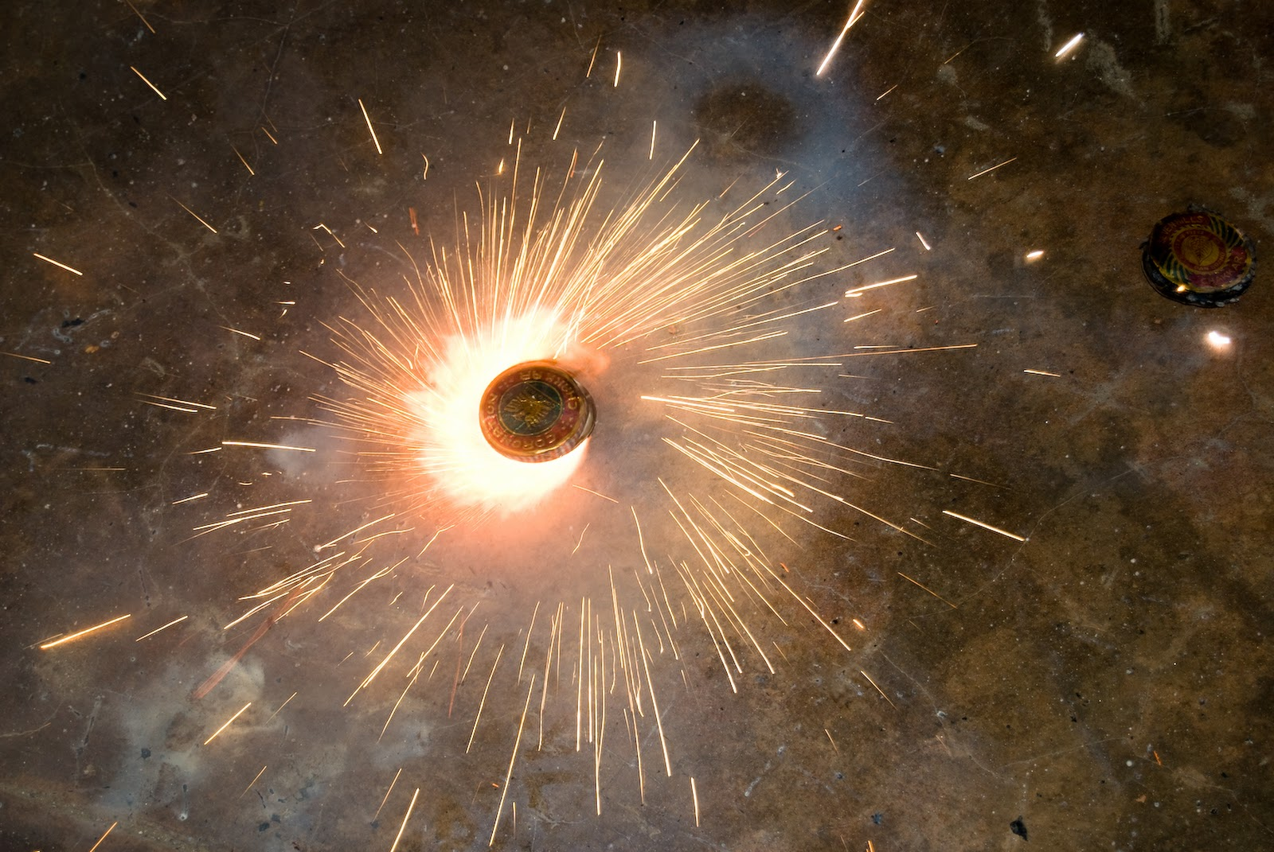
Lpac 16th 8pm
How far would you go?

The Wheel Of Control

These are the two posters I created for the Wheel of Control. The first poster picture is at the moment in the film were Kelly is being most risky. It shows mystery and doesn’t give too much away. The poster is also better looking and therefore hopefully more appealing to passers-by. The second one was our first draft. The wheel is going out of control and setting on fire. This was a good idea however aesthetically it was not as appealing as the first poster. It also lacked information and didn’t work as well as the first. I tried to make the wheel in the second poster look less like blocks of colour however within the time frame I had this was not possible and with the second poster being so perfect for the mystery we wanted to create we had to choose the first poster.

